**SOFTWARE ENGINEERING PROJECT**

* **Group Members:**

**Laiba Muhammad Ishaq (F2023266330)**

**Hafiza Laiba Shahzad (F2023266320)**

* **Section :**

**V-20**

* **Subject:**

**Software Engineering**

**University Of Management And Technology**

**Project Title:**

**Online Shopping Platform**

* **Objective:**

The objective of this project is to provide an intuitive, secure, and AI-powered online shopping experience, allowing customers to search, compare, and purchase products from multiple vendors.

Undertaken by:

Laiba M. Ishaq(F2023266330)

Hafiza Laiba(F2023266320)

Supervised by:

Shahabaz Qadeer

Starting Date:

17 Nov 2024

Completion Date:

08 Feb 2025

Tools Used:

Development Stack: MERN (MongoDB, Express.js, React.js, Node.js)

User Interface: Material-UI, Bootstrap, Figma, Canva

Frontend: HTML, CSS, JavaScript

Backend: Node.js and Express.js

Database: MongoDB

Cloud Storage: AWS, Cloudinary

---

Abstract:

The Next Gen Online Shopping Platform is a cutting-edge AI-powered e-commerce solution that provides personalized recommendations, smart product search, vendor analytics, and a virtual try-on feature using AR. Customers can browse products, compare prices across multiple vendors, track expenses, and experience AI-assisted styling through a Smart Mirror feature. Secure payments and fraud detection ensure a safe and seamless shopping experience.

---

Features & System Functions:

1. For Customers:

✅ AI-Powered Smart Search – Search products using filters like color, price, and brand.

✅ Price Comparison Tool – Compare prices for similar products across different vendors.

✅ Personal Finance Tracking – Track your spending and get insights on your purchases.

✅ AI Smart Mirror – Try out clothing and accessories virtually before buying.

✅ Secure Payments – Multiple payment options with encryption.

✅ Real-Time Order Tracking – Stay updated with notifications about order status.

2. For Vendors:

✅ Multi-Store Management – Manage multiple stores from a single dashboard.

✅ Inventory Management – Add, update, and delete product listings.

✅ Sales & Performance Reports – Get analytics on product performance.

✅ Promotional Offers – Run discounts and marketing campaigns.

3. For Administrators:

✅ Fraud Detection & Fake Product Identification – AI-based filtering for fake listings.

✅ Platform Security & User Data Protection – Secure customer & vendor data.

✅ Platform Performance Monitoring – Ensure a smooth shopping experience for all users.

---

System Architecture & Diagrams:

Use Case Diagrams – Customers, Vendors, and Admin interactions

Class Diagram – Key classes and relationships

Sequence Diagram – User actions (e.g., login, search, checkout)

ERD (Entity Relationship Diagram) – Database structure

---

Testing Plan:

Functional Testing – Verify all features (Search, Checkout, Payments, etc.)

Performance Testing – Ensure fast response times

Security Testing – Protect against fraud and data leaks

User Acceptance Testing (UAT) – Real users testing the platform

Use Case Diagram:

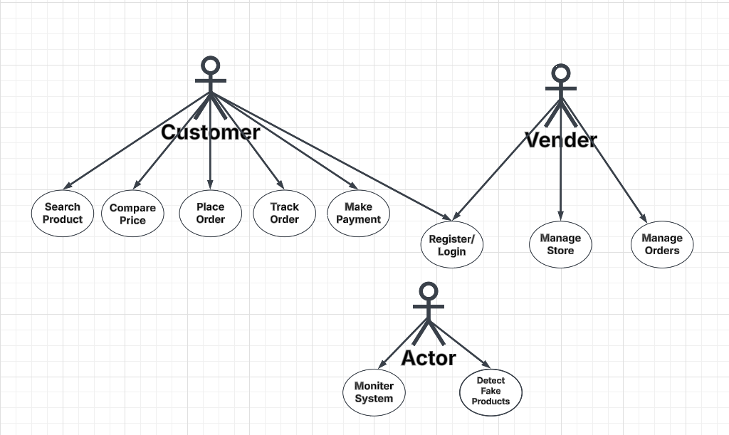

ERD Diagram:  
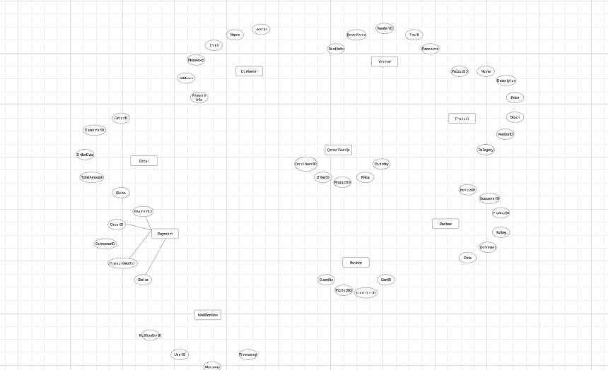

Conclusion & Future Work:

The Next Gen Online Shopping Platform aims to revolutionize online shopping with AI-powered search, smart styling, and secure transactions. Future improvements include voice-assisted shopping, blockchain-secured transactions, and AI-driven customer support.

**Uml Diagram**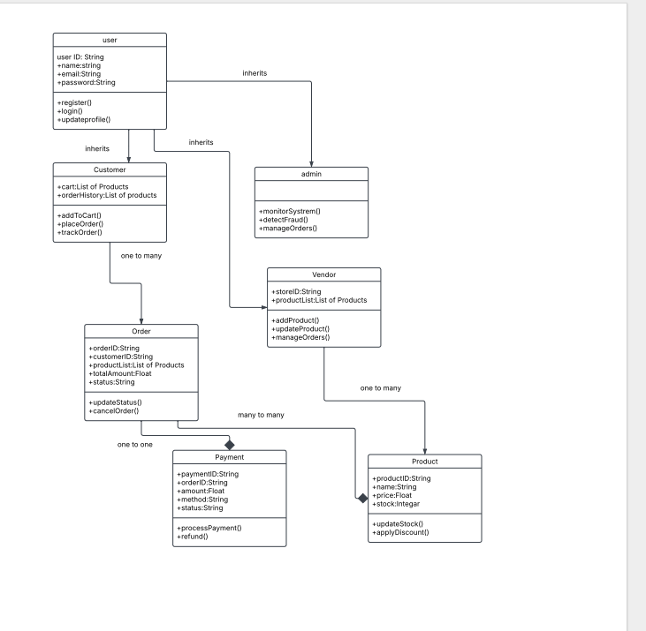

**Sequence Diagram**